FRESH BITES CATERING

REPORT

INTRODUCTION:

1.1.OVERVIEW:

Fresh Bites Catering, a catering service, utilizes Zoho Books to manage their sales, track inventory, and handle invoicing. They can generate professional invoices for clients and track expenses related to ingredients and supplies. Zoho Books helps them maintain accurate financial records and streamline their catering operations.

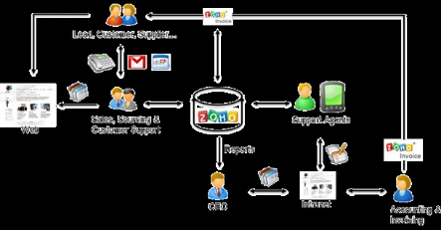

1.2PURPOSE:

Fresh bites catering,a catering service,utilizes zoho books to manage their sales,track inventory,and handle invoicing.They can generate professional invoices for clients and track expenses related to ingredients and supplies.

2 PROBLEM DEFINITION AND DESIGN THINKING:

1. Improving customer service…
2. ZOHO streamlines customer’s grievance redressal…
3. Measuring the business impact…
4. Improves collaboration between teams…
5. Access data at any time and from anywhere…

EMPATHY MAP: 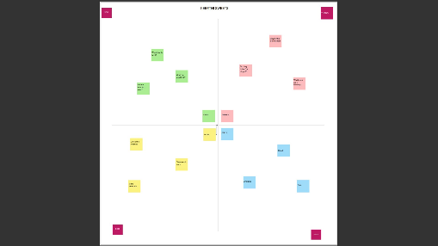

IDEATION & BRAINSTORMING MAP:

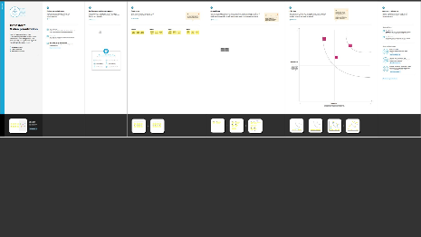

3.RESULT:

Output:

1.company name :fresh bites catering(shivani)

i) ITEM CREATION:

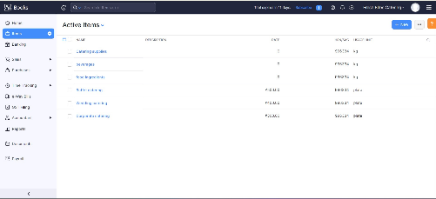

2.VENDOR CREATION:

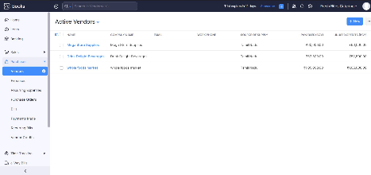

3.PURCHASE ORDER:

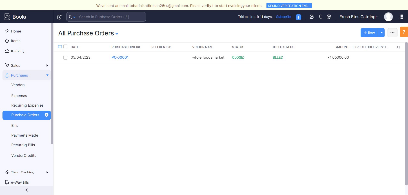

4.SALES ORDER:

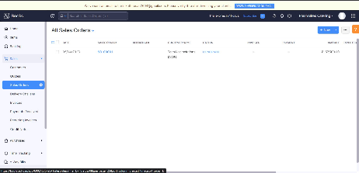

5.BANK DETAILS:

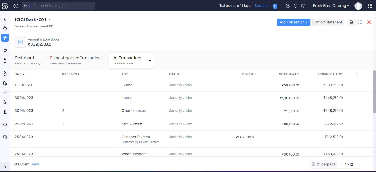

6.BALANCE SHEET:

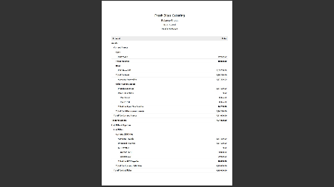

7.PROFIT AND LOSS ACCOUNT:

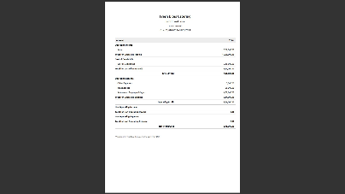

4.ADVANTAGES AND DISADVANTAGES:

* Monthly transaction cap. ...
* Multiple subscriptions for multiple businesses. ...
* Additional users require a fee. ...
* Fewer integrations than competitors. ...
* No payroll services. ...
* Accounts payable limitations.

5.APPLICATION:

Manage accounting on the go with zoho books IOS and Android apps.Do your accounting on the go using the mobile app for Ios,Android,and windows.

6.CONCLUSION:

ZOHO BOOKS PROVIDES FUTURE TECHNOLOGIES FOR GOING ON BUSINESS AND SUPPORTS STUDENTS PROJECT IT IS EASY TO USE AND ACCESS TOO.

7.FUTURE SCOPE:

THE PREFERENCES ARE FUTURE USEFUL THE ZOHO BOOKS.

8.APPENDIX:

A SOURCE CODE.

THE SOURCE CODE IS COMPUTER DATA.

1.Empathy Map & Brainstrom Link:

https://github.com/mtu121ucom046/preparation-and-maintenance-of-zogo-book-for-keerthi-sweets/commit/3b9a773613850807e3bf77e80f79e28776923012

2.Zoho Book link:

Book.zoho.com